**Question3: You have set up a new DHCP server within a Hyper-V virtual environment. Describe how you would configure the DHCP scope and options?**

**Answer:**

Configuring a DHCP scope and options in a Hyper-V virtual environment involves several steps:

**Step 1: Set Up the Hyper-V Environment**

* **Install Hyper-V Role:** Ensure the Hyper-V role is installed on your Windows Server.
* **Create a Virtual Switch:** In Hyper-V Manager, create an external virtual switch to allow virtual machines (VMs) to communicate with the physical network.

**Step 2: Set Up the DHCP Server**

* **Install DHCP Role:** On your server, open the Server Manager, go to the "Add roles and features" wizard, and install the DHCP Server role.

**Step 3: Configure the DHCP Server**

* **Open DHCP Console:** After installation, open the DHCP console from the Server Manager.

**Step 4: Configure the DHCP Scope**

* Create a New Scope.
* Right-click on IPv4 and select "New Scope".
* Follow the wizard:
  1. **Name and Description:** Provide a name and description for the scope (e.g., "Hyper-V Scope").
  2. **IP Range:** Specify the IP address range (e.g., 192.168.1.100 to 192.168.1.200).
  3. **Subnet Mask:** Define the subnet mask (e.g., 255.255.255.0).
  4. **Exclusions:** Add any IP addresses you want to exclude from the range.
  5. **Lease Duration:** Set the lease duration (e.g., 8 days).

**Step 5: Configure DHCP Options**

* Set DHCP Options:
* **Router (Default Gateway):** Enter the IP address of the gateway (e.g., 192.168.1.1).
* **DNS Servers:** Enter the IP addresses of DNS servers (e.g., 8.8.8.8 and 8.8.4.4).
* **Domain Name:** Specify the domain name (e.g., example.com).

**Step 6: Activate the Scope**

* Activate Scope:

1. Right-click on the new scope and select "Activate".

**Step 7: Configure Virtual Machines**

* Configure VMs to Use DHCP.
* Ensure your virtual machines are set to obtain an IP address automatically from the DHCP server.
* Connect your VMs to the virtual switch created earlier.

**PowerShell commands to configure DHCP scope and options:**

1. **Install DHCP Role:**

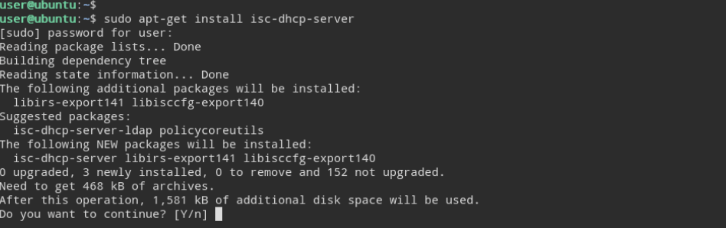

1. **DHCP Scope:**

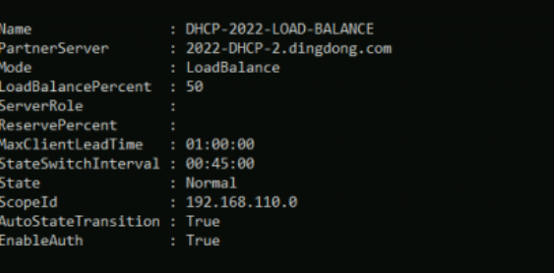

1. **DHCP Options:**

